Before writing any code, we decided to all agree on a common design for our website, and determine our workflow so we could collaborate and synchronise between each other. Our previous module incorporated Miro as a way to gather ideas and visualise them, so we all agreed it would be a good tool to settle on a core idea for the website. As per the specification our website should feature;

- animation

- validation

- cookies/LocalStorage

What types of websites make use of these elements? We began researching and determined the best use of these elements would be featured in an online marketplace, a storefront that would be responsible for handling customer details such as location, email or phone numbers. It would also be expected to store and process payment information.

With the backend conceptualised, what online marketplace would be expected to make heavy use of a modern, friendly user interface? We decided to focus on something that caters to one market; having a general web store (ie. Amazon) would be too broad and complex for this assignment, and would involve too much time spent on gathering assets and setting categories when only a few of each should be efficient.

Abhi settled on the idea of a used car dealership – the scope of content is kept small while allowing us to focus on modern elements such as animations and accessibility. His knowledge of cars also make our job of setting categories and gathering car images/details easier.

I set out to research common elements that would be found on car dealership websites and how they are navigated. Screenshots were gathered of a few dealership websites, preferably ones with a clean look and low complexity as we aren’t planning to incorporate every feature. Local dealerships had a common design language with categories kept at the top of the page at all times, with the content kept below. Animations are simple but effective which would keep navigation and accessibility easier.

Here are the websites we referenced;

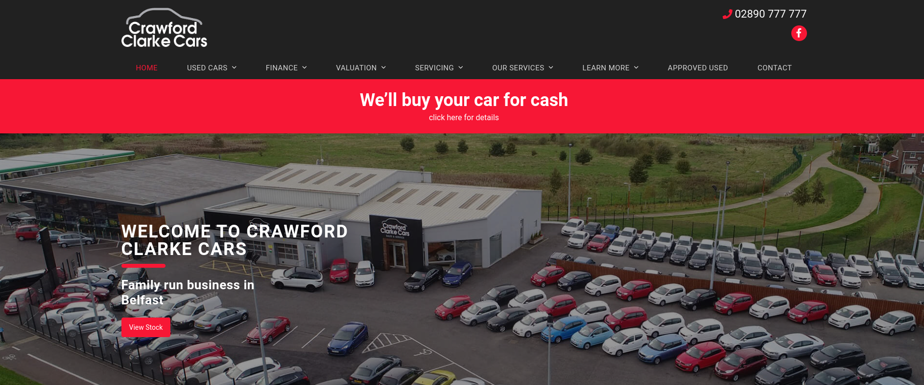https://www.crawfordclarkecars.co.uk/

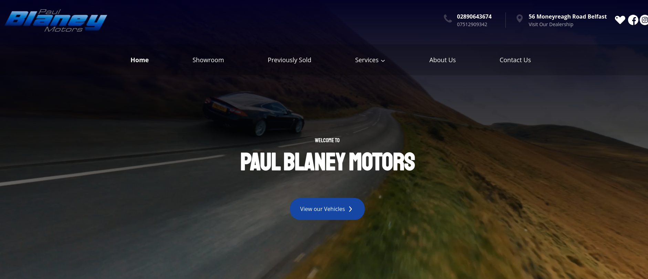

<https://www.paulblaneymotors.com/>

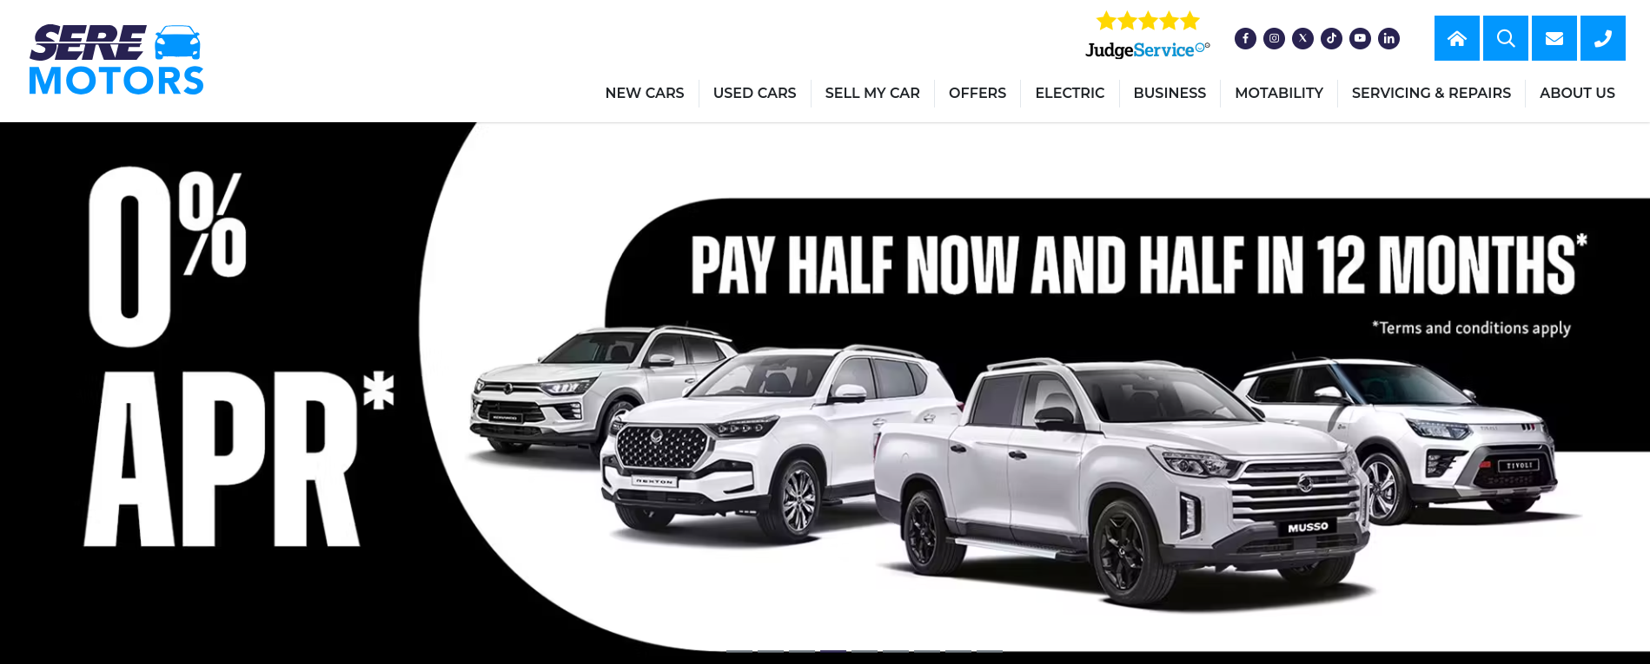

https://www.seremotors.com/

When gathering assets for the website, I aimed to keep everything consistent – colour schemes, the website’s general layout, and size and style of images. Images were somewhat difficult – every car is taken from a different angle and not all are transparent. This would pose an issue if we decide to change the background colour. I opted to search for images with consistent angles and lighting, and manually removing the background if necessary.

I also designed the website’s logo. A few drafts were made but tended to look somewhat simplistic and didn’t match the look other websites were going for.

In the end, this is the logo we settled on.

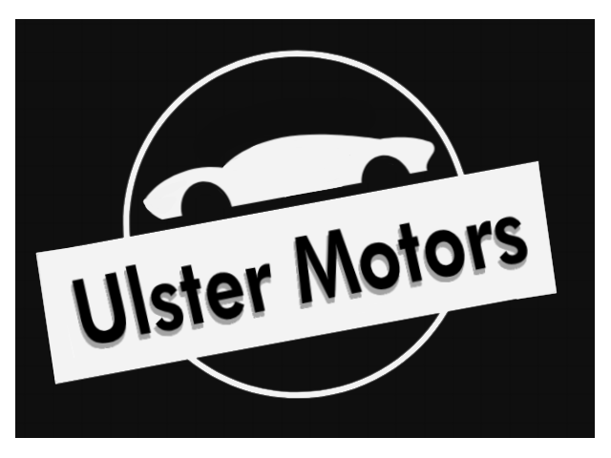

It has clear imagery to symbolise what the website is and stands out on most backgrounds we tested.

The favicon was created next – a simple vector greyscale graphic of car keys. Detail is kept to a minimum due to its small size.



We also needed a way to synchronise assets and code between each other. Originally we settled on a Visual Studio plugin called LiveCode but had issues getting it to work on everyone’s machine. We finally settled on using GitHub due to its version control and commit history, allowing us to track who contributed to which piece of code or assets. Any unwanted changes could also be reverted if needed. The only concern with this approach was making sure everyone would commit their changes manually so no work would be lost or replaced.